Purchase Specification Document for ERD1-09-03 Energy independent farm

  - Author: Bennamann
  - Date: 07/01/2021
  - File Name: Document1
  - Assembly lead: Duncan Glasby
  - Project lead: Chris Mann

  - Sign-off:
Role | Name | Date | Signature
Peer | Mohammad Abusara | 17/12/2020 | Verbal during meeting
Peer | Katie Shanks | 17/12/2020 | Verbal during meeting
Peer | Tom Bradshaw | 17/12/2020 | Verbal during meeting
Manager | Chris Mann | 07/01/2021

Quickbook codes
Project code | ERD1-09-03

Overview
As part of the European Regional Development Funded project, the Energy Independent Farm, Bennamann are seeking to procure of a Methane powered generator. We are looking to power a system that will power a maximum of 35kW for approximately 12h see the figure attached for the predicted daily power demand. We are looking to supply as much power as possible through renewable sources, though we need this running constantly to provide the grid voltage for the other inverters to run too. An ideal generator will be responsive to varying current demands as it will be run in conjunction with renewables.

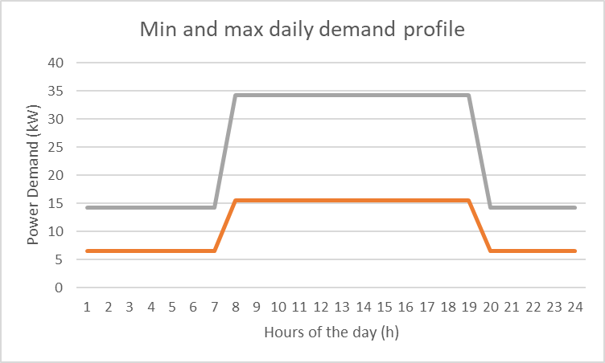
Figure 1: Daily demand profile of the grid.

Technical specification
Output:
Phase type: Three phase
Frequency: 50hz
Current type: AC
Voltage: 240V
Noise: <85db (desirable)

Deliverables
Fuel Usage at standby load.
Start-up power required. (not super critical but should be sensible for future work)

